SMART ENERGY MANGEMENT SYSTEM BASED ON IOT USING SMART GRIDS

Ms.J.Ruby Elizabeth
Department of Computer Science and Business System
Nehru Institute of Engineering and Technology
Mail-ID: nietjrubyelizabeth@nehrucollege.com
K.TamilSelvan Department of Computer Science and Business System
Nehru Institute of Engineering and Technology
Mail-ID: tamilselvankalirmm@gmail.com
J.Balamurugan Department of Computer Science and Business System
Nehru Institute of Engineering and Technology
Mail-ID: balamuruganofficalbala@gmail.com

M .Sainaveen
Department of Computer Science and Business System
Nehru Institute of Engineering and Technology
Mail-ID: sainaveen1707@gmail.com
A.P.Saravana Prakash
Department of Computer Science and Business System
Nehru Institute of Engineering and Technology Mail-ID: yandipazhani@gmail.com

Abstract- This paper presents an IoT-based Smart Energy Management System integrated with Smart Grid technology to improve energy efficiency and monitoring. The system uses sensors, smart meters, and microcontrollers to collect real-time data on energy consumption, which is transmitted to a cloud platform for analysis and visualization. A user-friendly dashboard enables remote monitoring and control of electrical devices. Automated load management helps reduce energy wastage and optimize power usage. The integration with Smart Grid supports better load balancing and demand response. The proposed system is cost-effective, scalable, and suitable for residential and commercial applications, promoting sustainable and efficient energy utilization.

- Introduction

The increasing demand for electrical energy due to rapid urbanization, population growth, and widespread use of
electrical appliances has created major challenges in efficient energy management. Traditional systems rely on manual
monitoring and centralized control, leading to energy wastage, delayed responses, and lack of real-time visibility,
resulting in higher costs and reduced efficiency.The integration of Internet of Things (IoT) technology has improved
energy management by enabling sensors, smartmeters, and embedded devices to collect and
transmit real time consumption data. This allows better analysis,informed decision-making, and remote control of
electrical devices, enhancing efficiency and convenience.

II. Literature Review

Recent advancements in energy management have been significantly influenced by the integration of Internet of Things (IoT) and Smart Grid technologies. Various studies have focused on improving energy efficiency through real-time monitoring, automation, and data-driven decision-making. IoT-based energy management systems have gained attention due to their ability to collect and transmit real-time data using sensors, smart meters, and embedded devices.

Hiremath and Kumar (2015) proposed an IoT-based home energy management system that integrates smart meters with cloud platforms to monitor and control energy consumption. Their work demonstrated improved user awareness and reduction in energy wastage through real-time feedback. Similarly, Arun Joy and Manivannan (2016) developed a smart energy scheduling system that optimizes load distribution by shifting energy usage to off-peak hours, thereby reducing peak demand and operational costs.

Al-Ali et al. (2015) introduced an IoT-based smart home system using wireless communication technologies such as Zigbee, enabling remote monitoring and control of appliances through mobile applications. Their system emphasized user convenience and automation in energy management. In addition, Arvindan and Kirubakaran (2015) designed a smart energy meter with two-way communication, allowing real-time data transmission between consumers and utility providers.

Despite these developments, existing systems face several challenges. Many solutions lack scalability and are limited to small-scale applications. High implementation costs and interoperability issues between different devices and protocols remain significant barriers. Furthermore, most systems focus primarily on monitoring and lack advanced analytics or predictive capabilities.

These limitations highlight the need for a comprehensive, cost-effective, and scalable solution that integrates real-time monitoring, automation, and intelligent analytics. The proposed system addresses these gaps by combining IoT technologies with Smart Grid infrastructure to provide an efficient and intelligent energy management solution.

III. Existing System

In traditional energy management systems, monitoring and control are largely manual and reactive. Most systems rely on conventional meters and periodic inspections, which do not provide real-time insights into energy consumption.Existing systems suffer from several drawbacks. They lack real-time monitoring capabilities, making it difficult to track energy usage dynamically. There is minimal automation, requiring users to manually control electrical devices, which leads to inefficient energy usage. Additionally, these systems do not provide analytical insights or predictive capabilities, limiting their ability to optimize energy consumption.Another major limitation is the absence of integration with modern communication technologies. Traditional systems do not support remote access or smart grid communication, reducing their effectiveness in large-scale applications. These issues highlight the need for an advanced system that can provide real-time monitoring, automation, and intelligent decision-making.

IV. Proposed System

The proposed system is an IoT-based Smart Energy Management System integrated with Smart Grid technology, designed to provide real-time monitoring, automation, and efficient energy utilization.

The system consists of IoT-enabled devices such as sensors, smart meters, and microcontrollers that continuously monitor electrical parameters like voltage, current, and power consumption. The collected data is transmitted to a cloud platform using communication protocols such as MQTT and HTTP. The cloud platform processes the data and provides insights through a user-friendly dashboard.

Automation is a key feature of the proposed system. Based on predefined rules or real-time conditions, the system can automatically control electrical loads using relay modules. This helps in reducing energy wastage and optimizing power consumption.

The system also supports remote monitoring and control through web or mobile applications, allowing users to access energy data and manage devices from anywhere. Integration with Smart Grid enables better load balancing, demand response, and efficient energy distribution.

A. Hardware Requirements
The hardware components include a microcontroller such as ESP32 or Arduino, which acts as the central processing unit. Sensors like current transformers and voltage sensors are used to measure electrical parameters. Relay modules are used for controlling electrical loads. A stable power supply unit ensures proper functioning of all components.

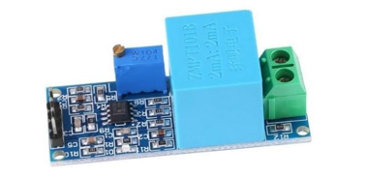

Figure 1: AC Voltage Sensor
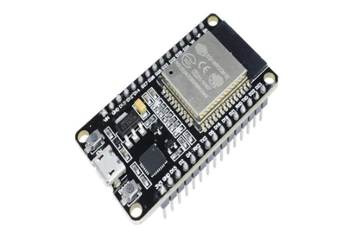

Figure 2: ESP 32 Wi-Fi Module

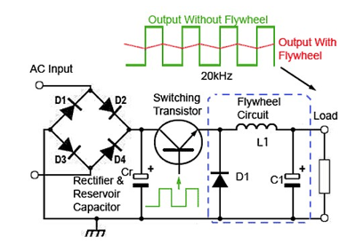
Figure 3: Buck converter circuit

B. Software Requirements
The software component includes embedded firmware developed using Arduino IDE or similar platforms for data acquisition and communication. A cloud-based backend is used for data storage and analytics. A web or mobile dashboard is developed using technologies such as HTML, CSS, JavaScript, and backend frameworks like Flask or Node.js to provide visualization and control features.

The proposed system offers several advantages, including real-time monitoring, automated control, reduced energy consumption, cost savings, and scalability. It provides an efficient and intelligent solution for modern energy management challenges.
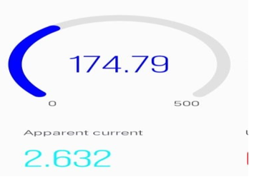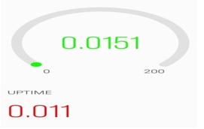

Figure 4: voltage meter measurement Figure 5: kwh meter measurement with uptime

V.Methodology

The methodology adopted for the IoT-Based Smart Energy Management System using Smart Grid is organized as a step-by-step process to ensure efficient design, implementation, and evaluation of the proposed solution. Initially, the system requirements are identified by analyzing the need for real-time energy monitoring, intelligent load control, reduced wastage, and user-friendly operation in residential and commercial environments. Based on these requirements, a multi-layer architecture is designed that connects sensing devices, embedded controllers, communication modules, cloud services, and user interfaces into a unified framework.

In the hardware layer, sensors and smart meters are selected to measure important electrical parameters such as voltage, current, and power consumption. Microcontrollers are used to collect these readings, perform local processing, and communicate with the central system. Relays or smart switches are included to enable automated control of electrical loads. These hardware components are carefully assembled and calibrated to ensure accurate and reliable data acquisition.

For communication, lightweight IoT protocols such as MQTT and HTTP are used to transfer sensor data from the devices to the cloud platform. In the software layer, embedded firmware is developed for continuous data acquisition, processing, and transmission. A cloud-based backend is then configured to store incoming data, analyze usage patterns, and support decision-making. This analytics layer helps in identifying consumption trends, predicting energy behavior, and triggering automated actions for energy optimization.

To improve usability, a web or mobile dashboard is developed for real-time visualization of energy usage, remote appliance control, alert notifications, and user interaction. Finally, the entire system undergoes unit testing, integration testing, and performance evaluation to verify accuracy, responsiveness, reliability, and scalability. After successful validation, the prototype is deployed in a real or simulated environment to assess its practical impact on energy savings, operational efficiency, and smart energy management.

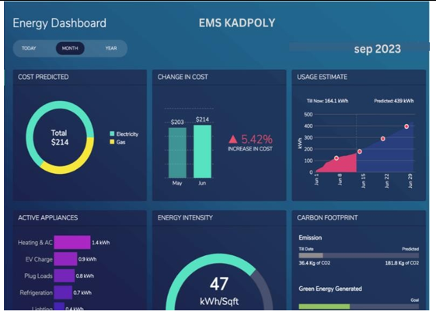

Figure:6-Real time data interface

VI. Conclusion

The IoT-based Smart Energy Management System using Smart Grid demonstrates an effective approach to improving energy efficiency and reducing wastage. By integrating IoT devices, cloud computing, and smart grid technologies, the system provides real-time monitoring, automated control, and data-driven insights.
The implementation results show that the system enhances user awareness, optimizes energy usage, and reduces operational costs. The ability to remotely monitor and control appliances further improves convenience and efficiency.Although the system is effective, future enhancements can include the integration of machine learning for predictive analytics, improved security mechanisms, and support for renewable energy sources. With these advancements, the system can be extended to large-scale applications such as smart cities and industrial energy management.Overall, the proposed system provides a scalable, cost-effective, and intelligent solution for modern energy management, contributing to sustainable and efficient energy utilization.

VIII. References

- Internet of Things for Energy Management in the Home Power Supply — Mahesh Hiremath & Manoranjan Kumar, 2015. This paper describes an architecture for home energy management using IoT: a smart meter + embedded device (with GPRS) + cloud storage to monitor and control loads, and switch between grid and renewable energy supply. “Low-power and area-efficient carry select adder" by B. Ramkumar and H. M. Kittur, IEEE Transactions on VLSI Systems, 2012.
- Energy Management System using IoT — S. Ilaveni, J. Jey Amani, C. Immaculate Shirly, R. Karthika (2017, but rooted in earlier IoT-EMS research). This work proposes controlling and monitoring home appliances remotely using IoT plus microcontroller-based sensing, to reduce energy consumption.
- Smart Energy Management and Scheduling using Internet of Things — Arun Joy & D. Manivannan, 2016. Focused on real-time monitoring and scheduling of energy usage in buildings, using IoT.
- IoT Based Smart Energy Meter for Efficient Energy Utilization — P. Arvindan & D. Kirubakaran, 2015 This paper presents an IoT-enabled smart energy meter designed for twoway communication between users and utilities. It uses an embedded microcontroller and WiFi/GSM to transmit consumption data to a cloud server in real time
- Smart Energy Management System for Home Appliances Using IoT — K. S. Sudeep & N. D. Alex, 2016. The authors propose a microcontroller-based platform that enables remote monitoring and switching of home appliances using IoT connectivity
- IoT Based Energy Efficient Smart Home Control System — A. R. Al-Ali, Imran A. Zualkernan & F. Aloul, 2015. This work presents a prototype smart home energy management system that uses IoT wireless modules (ZigBee) connected to household devices. Users monitor and control energy use through a smartphone app.
- An IoT-Based Electrical Energy Monitoring System — A. Srikanth & T. Poongothai, 2015.The paper introduces a cloud-connected system for continuous monitoring of electrical parameters such as voltage, current, and load consumption. Data is pushed to an IoT platform, where users can access device-level usage statistics. The work shows how real-time analytics can support fault detection and preventive maintenance in residential and small industrial settings.

